

UND Wildlife at Home Education Modules

Lesson Title – Construct a food web using Grouse depredation videos from a study in Western ND.

|  |  |  |
| --- | --- | --- |
| Brief Description |  | Core Ideas |
| Primary Standard Addressed | 5-LS2 Ecosystems: Interactions, energy, and Dynamics | LS2.A: Interdependent Relationships in Ecosystems  ▪ The food of almost any kind of animal can be traced back to plants. Organisms are related in food webs in which some animals eat plants for food and other  animals eat the animals that eat plants. Some organisms, such as fungi and bacteria, break down dead organisms (both plants or plants parts and animals) and therefore operate as “decomposers.”  Decomposition eventually restores (recycles) some materials back to the soil. Organisms can survive only in environments in which their particular needs are met. A healthy ecosystem is one in which multiple species of different types are each able to meet their needs in a relatively stable web of life. Newly  introduced species can damage the balance of an ecosystem. (5-LS2-1)  LS2.B: Cycles of Matter and Energy Transfer in Ecosystems  ▪ Matter cycles between the air and soil and among plants, animals, and microbes as these organisms live and die. Organisms obtain gases, and water, from the  environment, and release waste matter (gas, liquid, or solid) back into the environment. (5-LS2-1) |
| Supporting Standard(s) | 5-LS2-1  Develop a model to describe the movement of matter among plants, animals, decomposers, and the environment | Systems and System Models  ▪ A system can be described in terms of its components  and their interactions. (5-LS2-1) |
| Pre-assessment |  | 1. Where almost all energy in a food chain ultimately come from? 2. What is an example of a primary producer? 3. What is an example of a primary consumer? 4. What is an example of a secondary consumer? 5. What is an example of a tertiary consumer? 6. What is the definition of “prey”? 7. What is the definition of “predator”? 8. Can an organism fill more than one role in an ecosystem? 9. What do the arrows represent in a food chain or food web? 10. Define *herbivore, carnivore,* and *omnivore*.   Students will be given a *prequiz* asking them to identify answers to the above questions. |
| Part 1: Background | Introduce students to background information about Sharp-tailed Grouse and their history on the ND Landscape using the *Background Information* handout below. |  |
| Part 2: Brainstorm | Have students construct 2 lists. The first should be a list of what they think Sharp-tailed Grouse eat. The second should be a list of what they think eat Sharp-tailed Grouse |  |
| Goal and Objective #1 | * Students should now be able to construct a model of a simple food chain similar to the outline provided as *Student Handout 1*. | NOTE: Not everyone’s needs to be the same. |
| Assessment #1 | Upon completion of part 1 and 2 above, students will be presented with a sample food chain, and asked to answer where the energy for the food chain originally comes from. They will also be asked to identify what a primary producer, and a primary, secondary, and tertiary consumer are based on the food chain. Students will also be asked to define predator and prey. | On *Student Handout 1* have students identify what a primary producer, and a primary, secondary, and tertiary consumer is based on the food chain. Students will also be asked to define predator and prey |

|  |  |  |
| --- | --- | --- |
| Goal and Objective #2 A | * Once students have mastered a simple food chain, they should be interpret a more complex food web. * Using *Student Handout 2* students should be able to identify a variety of relationships.   For example, starting with berries in the lower right, energy and matter can flow to the grouse, then to the badger. This represents a simple food chain where the grouse is a primary consumer, and the badger is a secondary consumer.  Alternatively, If we start with the same berries, which get consumed by grasshoppers, who then get eaten by rats, who then get eaten by a badger, the badger is now acting as tertiary consumers. | Provide students with a copy of *Student Handout 2*. Have them draw in their own arrows to illustrate the following: |
| Assessment #2 A | See *Handout 2*  With *Student Handout 2*, students should be able to trace relationships from primary producers (plants) through the final consumers in a manner that demonstrates how organisms can occupy more than one trophic level in a food web. This should demonstrate the complex interactions of a food web within an ecosystem. | 1. How can a hawk act as a secondary consumer?   ANS: plant to rat to hawk   1. How can a hawk act as a tertiary consumer?   ANS: plant to ground squirrels to snakes to hawk   1. How can a hawk act as a quaternary consumer?   ANS: plant to grasshopper to rat to snake to hawk |
| Goal and Objective #2 B | Have students create their own food web by either adding their brainstormed ideas from part 2 above to the existing handout, or creating a new one of their own. |  |
| Assessment #2 B | Examine modified or new food web for correct and appropriate relationships. | Student should be able to correctly add animals to their food web in a manner that depicts their role in the ecosystem. |
| Goal and Objective #3 | Utilizing the brainstormed list from above, and the food web that students have now constructed, it is time to utilize the Wildlife@Home page hosted and developed by UND.  Students can be directed to the webpage [***XXXYYY@und.edu***](mailto:XXXYYY@und.edu)  Have students view the “highlight reel” of nest depredation events, and identify each predator they see.  Once all events have been viewed and all predators classified, have students compare the list of predators they identified in the videos to those they initially thought may have been predators. | #1. Were there any predators they identified in the videos that were not on their original list? If so, add them to their food web.  #2. Were there any predators on their original list that did not appear in the videos? Create a list of these.  #3 Just because we did not capture any videos of the predators in #2, does that mean those organisms do not prey on sharp-tailed grouse?  #4. Note that there were no humans captured in the videos. Why is it so important to have regulatory agencies setting seasons and bag limits on species such as Grouse? |
| Goal and Objective #4 | Using the food web developed above, it is now time to discuss relationships between different trophic levels.   * When posed with two competing hypothesis about the impacts of a change to the food web, students should be able to evaluate both, and defend the one they feel is more accurate. | EX 1: Grouse and rats are both eaten by a variety of predators such as badgers, coyotes, and hawks. Above average rainfall this year has resulted in a booming rat population in some areas of western ND. Will this booming rat population A) increase, B) decrease, or C) have no effect on the grouse population?  Students should be able to select one of the choices and defend why they feel this one is correct. |
| Assessment #4 |  |  |

Materials

Sharp-Tailed Grouse Ecology and Information by Adam Pach and Chris Felege

Sharp-tailed Grouse (*Tympanuchus phasianellus*) are medium sized, ground-nesting birds who usually weigh an average 880 g (Sibley 2000). This makes them about half the size of a chicken. The coloration is a drab gray-brown mottled with white. Both sexes have horizontal or v-shaped markings on the breast, a slight crest on the head, white spots on the wings, light colored flanks and belly, and feathered legs (Johnson and Knue 1989). Males have purple air sacs on the side of the neck and a yellow comb above the eyes, both of which are only visible during mating season. Wings are short and rounded, used for short bursts of flight followed by gliding. The tail is pale and pointed.

Distribution

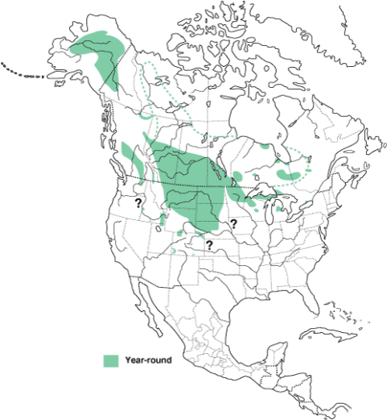

Sharp-tailed Grouse can be found from Alaska, east to East Central Canada, south through Michigan, Minnesota and Wisconsin, and west to Southern Colorado and Utah. Sharp-tailed Grouse prefer open, fairly treeless areas that contain a mix of dense grasses, forbs, and shrubs. Habitat is chosen based on openness and plant density (Marks 2007).

Nesting habitat of grouse depends on what is available to them. Some studies have suggested that grouse prefer to nest near areas with taller, denser shrubs. This is not a necessity for a successful nest, as many females will select areas with lower shrub cover but a higher level of forbs (Goddard et al. 2009). The extra cover provided by the shrubs or dense forbs is most important during the first 14 days after chicks hatch, which is when offspring survival rates are the lowest due to predation and adverse weather (Goddard and Dawson 2009).

Ecology

### Diet

The diet of adult grouse is comprised mainly of plant material, including buds, flowers, and seeds. A small portion of the adult diet consists of insects, including ants, beetles, grasshoppers and crickets (Marks 2007). Chicks however are thought to feed heavily on insects because this helps promote feather development. The only months when grouse do not consistently feed on the ground are the winter months when snow covers these food sources. During these months, grouse will often forage in shrubs and trees.

### Reproduction

Sharp-tailed Grouse are among four species of North American grouse that congregate in specific areas, known as leks, to engage in elaborate mating rituals known as 'dancing' (Videos are available at this link https://www.youtube.com/watch?v=vCEQgpzNPBY). Mating is based on selection of suitable males, who take part in the displays, by females, who do not display but rather observe male displays and choose a mate. The size of a lek is relatively small, ranging from as small as a small house or as large as a baseball diamond. Leks are traditionally used for multiple years, although if the habitat is no longer suitable a new lek may be formed elsewhere. A lek is usually found within 1-2 kilometers of denser grass cover, which is necessary for nesting materials and cover (Prose 1987). Leks often have low, sparse vegetation, allowing for clear vision in all directions and adequate space to engage in dancing, as well as vision to help escape and minimize predation. Areas that are often used for leks include rangeland, harvested or low cropland, low ridges and knolls, recent burns, and even abandoned runways (Prose 1987).

Beginning in March he males gather on the lek in the morning beginning at roughly 30 minutes before sunrise and begin to “dance”, displaying to try and attract a female. The dancing ritual by the males is highly elaborate, and students are encouraged to use internet resources such as Youtube, to view some of the spectacular footage available (one link is provided above, but there are many available).

Once a mate is attracted, the hen will usually her first fertilized egg within 1-3 days with an additional egg being laid every 1-2 days. Clutch sizes average 11-12 eggs. Once laying is complete the hen will incubate the eggs for 21-25 days. Despite being laid days apart, the eggs all hatch at roughly the same time due to incubation starting only after the last egg has been laid. The precocial young (born well developed with feathers, eyes open, and ready to leave the nest shortly after hatch) will leave the nest within 24 hours of hatching (Roersma 2001).

### Predation

Common nest predators include coyote (*Canis latrans*), striped skunk (*Memphitis memphitis*), a variety of ground squirrels, and common ravens (*Corvus corax*). A variety of hawks, and owls are also thought to prey upon sharp-tailed grouse. Current research at The University of North Dakota is attempting to shed more light on interactions between these predators and sharp-tailed grouse. Information is available at the Wildlife@Home website.

## Conservation

Sharp-tailed grouse populations are in decline in many areas, but this decline is not considered to be a major concern yet. Many states and provinces that have Sharp-tailed Grouse populations have a hunting season on the bird because the population is currently thought to be sustainable.

One major factor contributing to the declines noted is habitat loss. Two different factors play into this. First, many acres of grassland are being converted for agriculture. Second, grouse will move away from an area if too much woody vegetation is present. This is especially evident in areas with leks, where males will abandon a lek where even small increases of woody vegetation have occurred (Hanowski et. al. 2000). Furthermore, recent expansion of gas and oil development in western North Dakota may result in fragmentation of the vast grasslands favored by sharp-tailed grouse, as well as frequent disturbances such as noise, additional lighting, and dust.

For more information on these animals and the habitat they live in, you can also view the training videos for identifying sharp-tailed grouse, their nests, and their predators by visiting the Wildlife@Home webpage hosted by UND at http://volunteer.cs.und.edu/csg/wildlife/.

Prequiz Grade 5

5-LS2 Ecosystems: Interactions, Energy, and Dynamics

1. Where does almost all energy in a food chain ultimately come from?
2. What is an example of a primary producer?
3. What is an example of a primary consumer?
4. What is an example of a secondary consumer?
5. What is an example of a tertiary consumer?
6. What is the definition of “prey”?
7. What is the definition of “predator”?
8. Can an organism fill more than one role in an ecosystem?
9. What do the arrows represent in a food chain or food web?
10. Define *herbivore, carnivore,* and *omnivore*.

Student Handout 1

Fill in the following using the terms provided:

Sun, primary producer, primary consumer, secondary consumer, tertiary consumer

#1.

#2.

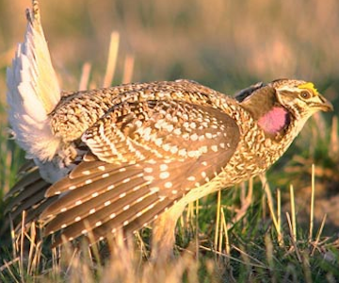

#3.

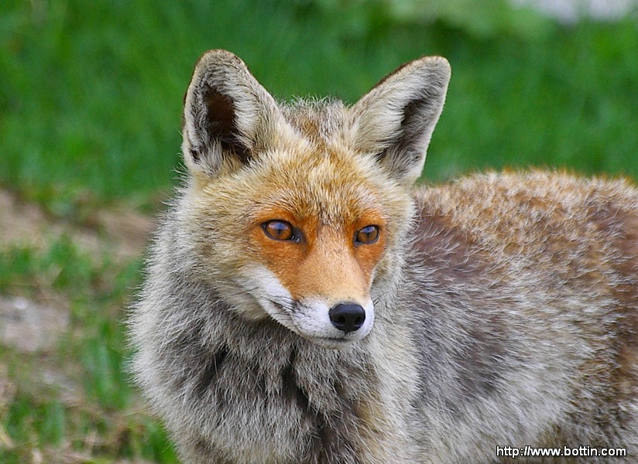

#4.

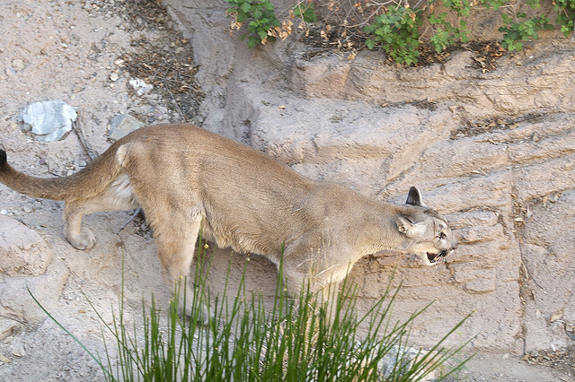

#5.

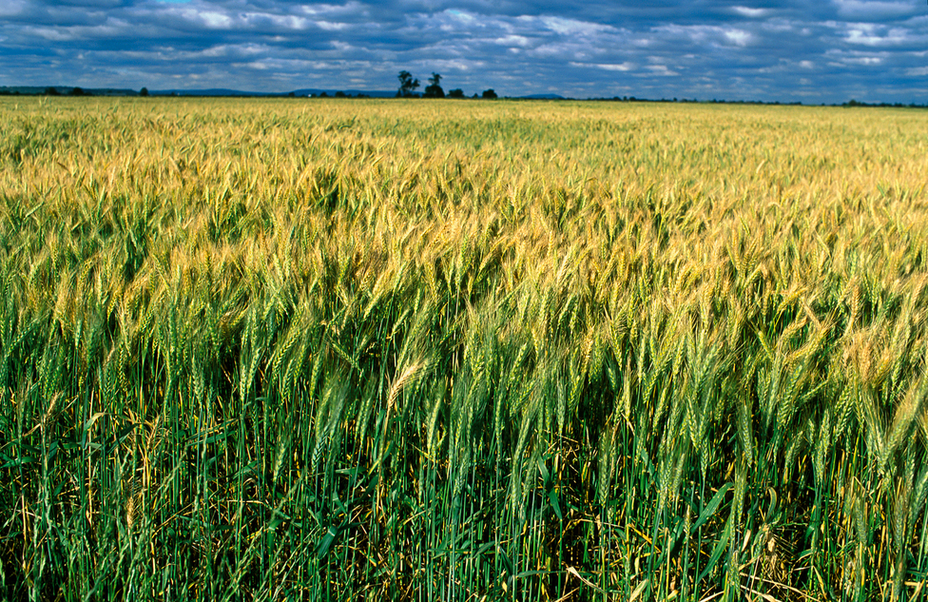

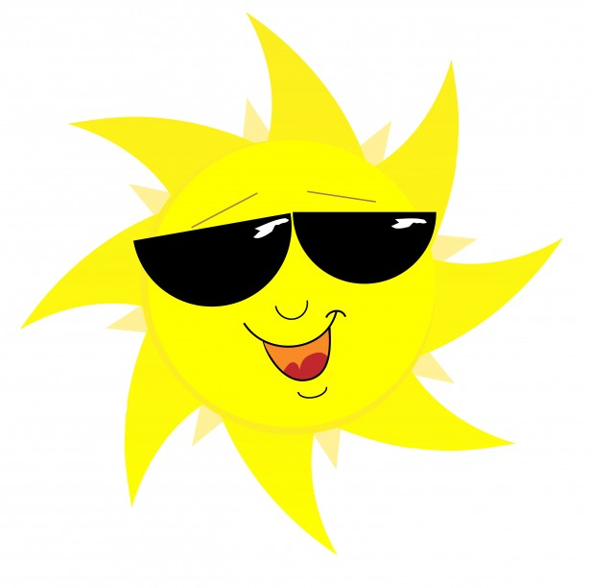

Define the following, and provide one example of each:

Predator:

Prey:





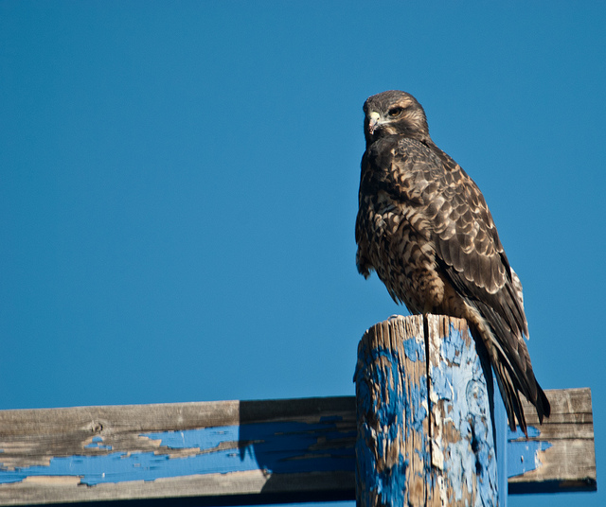

Student Handout #2

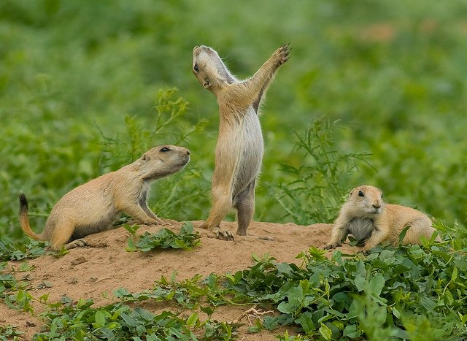



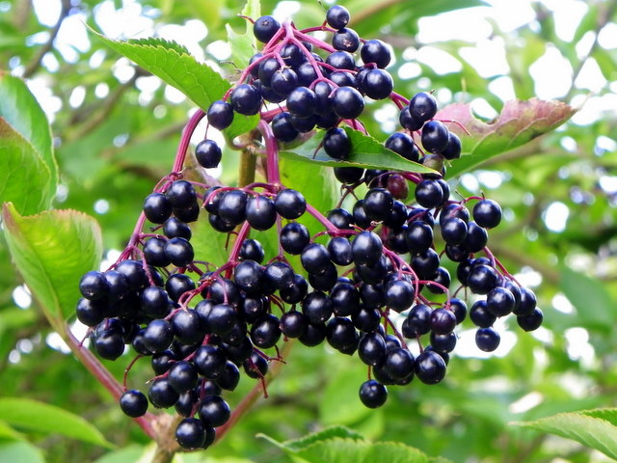

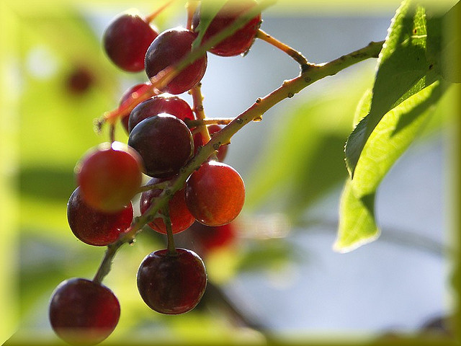

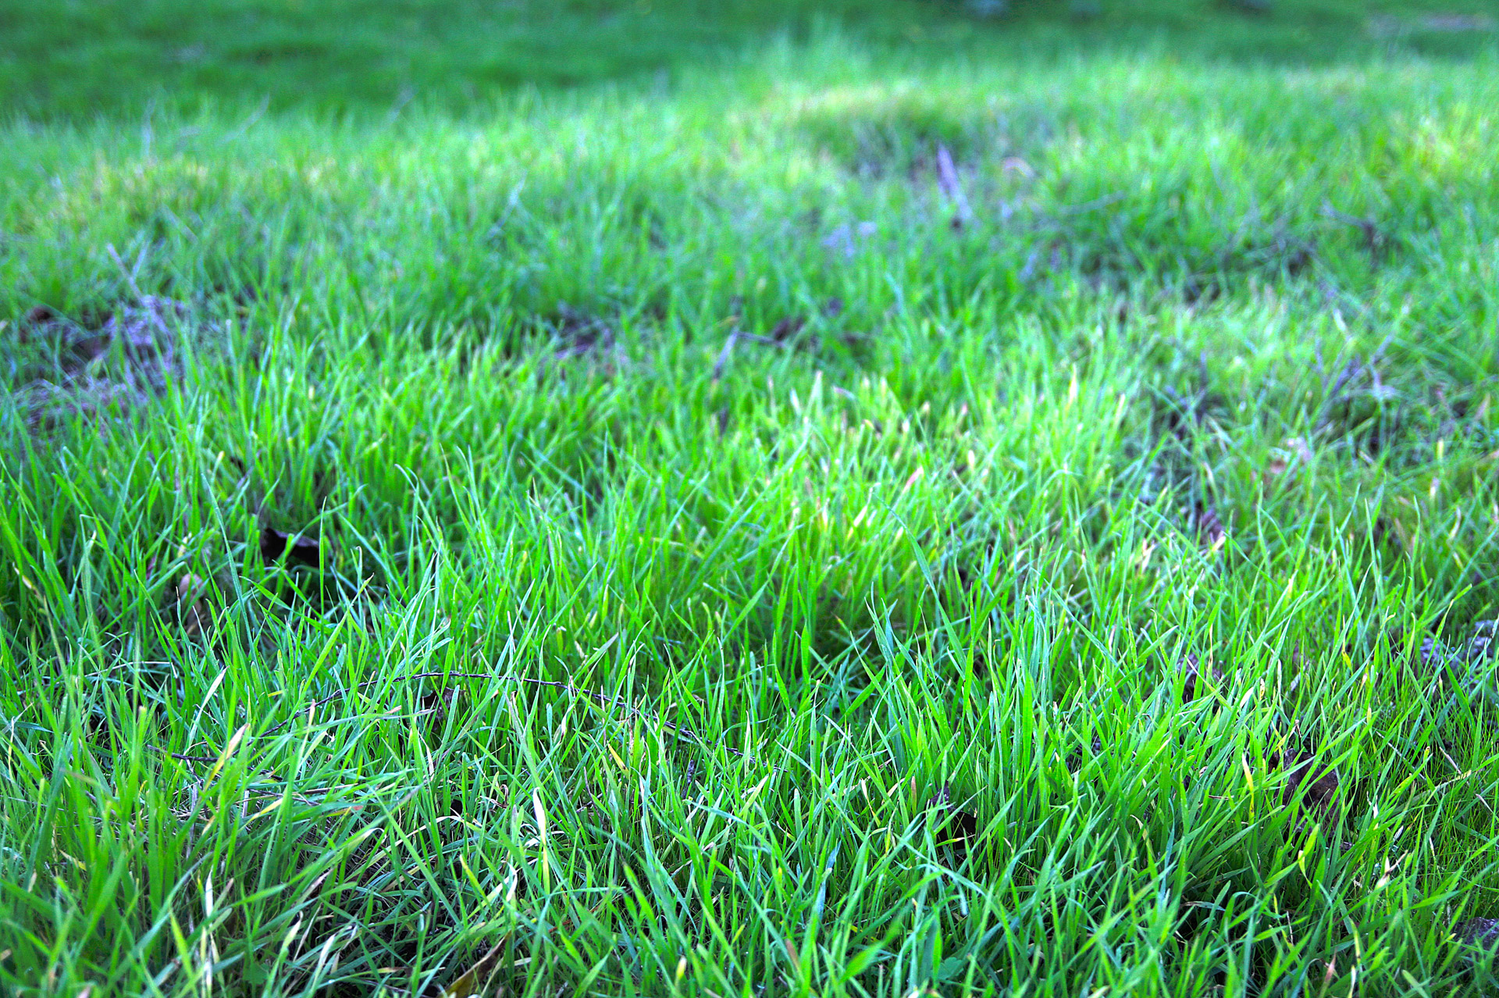



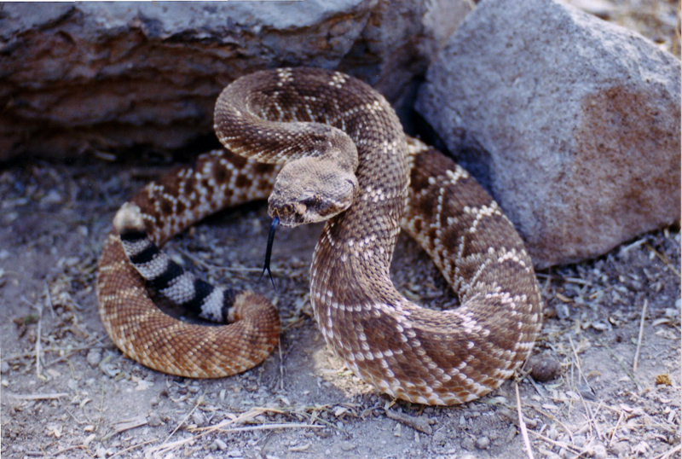



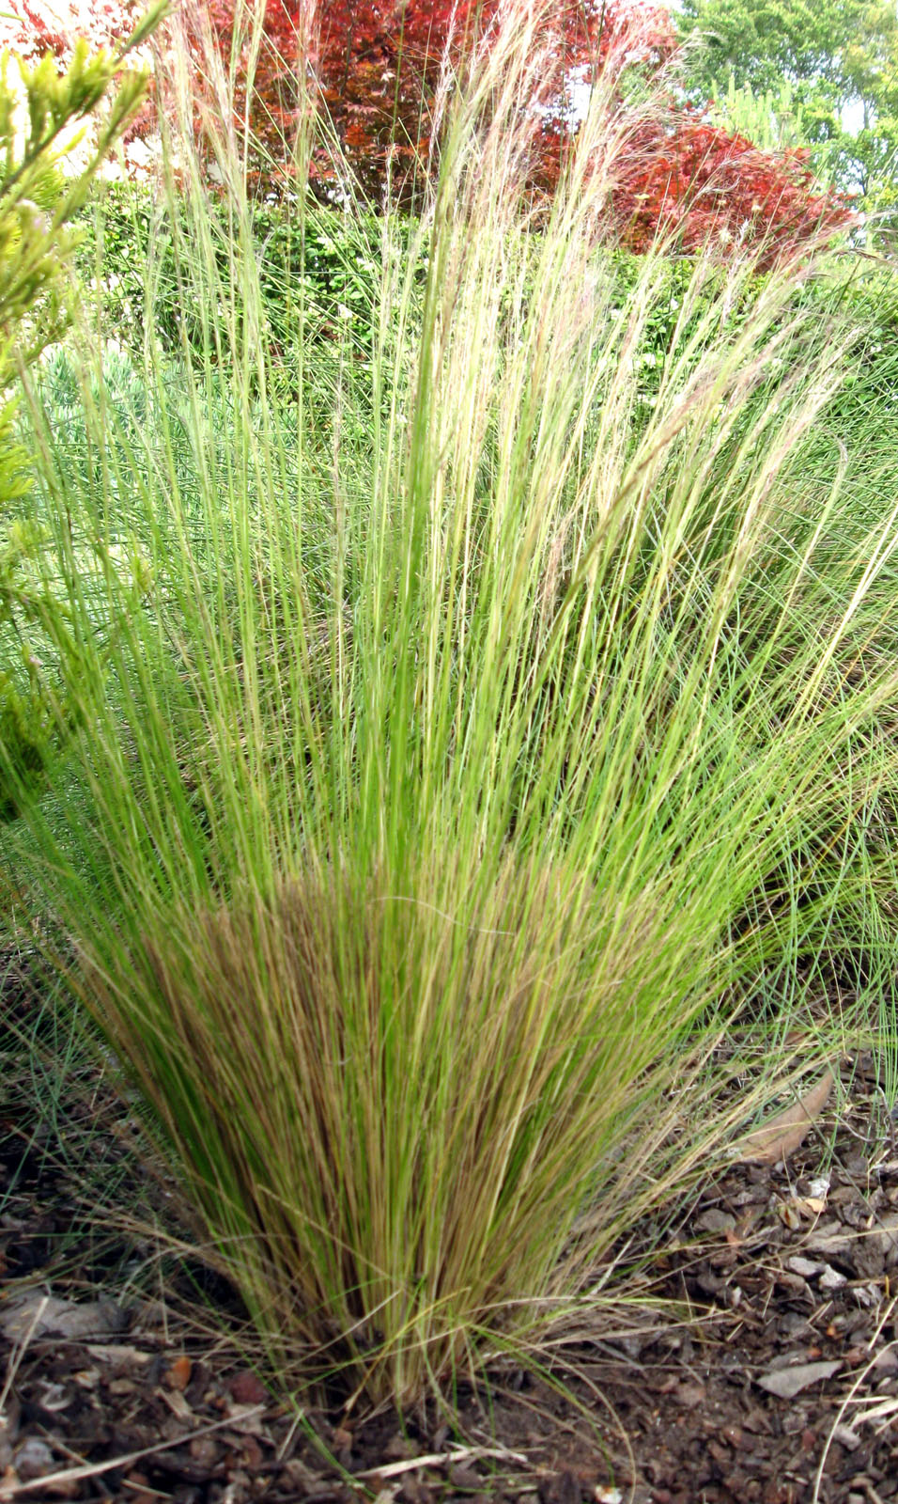

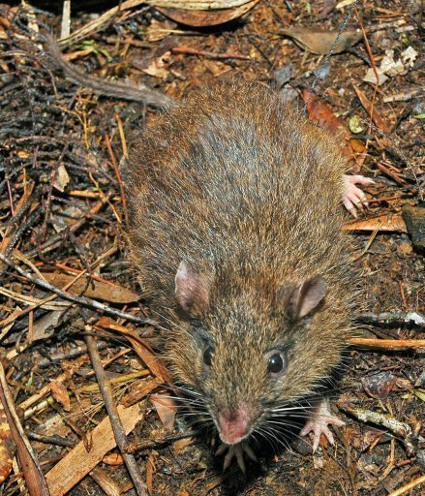

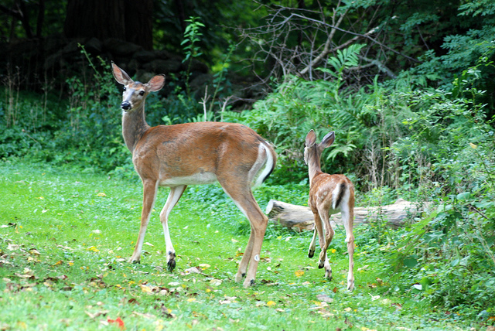

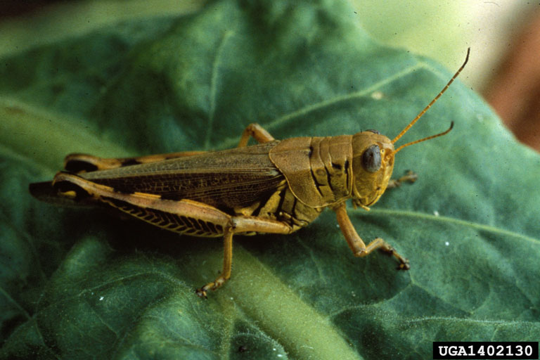

Student handout #3

1. Were there any predators you identified in the videos that were not in your original brainstormed list? If so, please add them to your food web now, and list them in the space below.
2. Were there any predators on your original brainstormed list that that did not appear in the videos? If so, please create a list of these in the space below.
3. Look at your list in #3 above. Does the fact that no videos were captured of your suspected predator(s) mean that those organisms do not prey on sharp-tailed grouse? Explain why we may not have gotten a video of this.
4. Note that there were no humans captured in the videos. Why is it so important to have regulatory agencies setting seasons and bag limits on species such as Grouse?

Extension

Grouse and rats are both eaten by a variety of predators such as badgers, coyotes, and hawks. If above average rainfall resulted in a booming rat population because of an increase in berries in some areas of western ND, will this booming rat population A) increase, B) decrease, or C) have no effect on the grouse population, and why?

Select one of the choices and defend your answer.

Post-Assessment

1. Where does almost all energy in a food chain ultimately come from?
2. What is an example of a primary producer?
3. What is an example of a primary consumer?
4. What is an example of a secondary consumer?
5. What is an example of a tertiary consumer?
6. What is the definition of “prey”?
7. What is the definition of “predator”?
8. Can an organism fill more than one role in an ecosystem?
9. What do the arrows represent in a food chain or food web?
10. Define *herbivore, carnivore,* and *omnivore*.

Using the food web below, please answer the following:

Berries Grouse Rattlesnake Hawk

Match the term below with the box above:

1. Primary producer C) Tertiary Consumer E) Quaternary Consumer
2. Primary Consumer D) Secondary Consumer

Using the food chain above, explain what would happen to the hawk population if a dry summer caused the berry bushes to produce half the usual amount of food.